Noah Foilb

Chapter 2 questions

2.27

A) It will decrease since it is smaller than the current mean

B) (24 x 74 + 1 x 64)/ (24 + 1) = 73.6

C) It will increase since it is more than one standard deviation away.

2.28

A) using a frequency table, we find the Q1 is around 5, the median is around 15 and Q3 is 35

B) It is right skewed

2.29

A) I would expect it to be right skewed because it would be impossible for people to watch less then 0 hours of television.

2.30

A) It would be a symmetric distribution

B) This will be negatively skewed

C) This will be positively skewed

2.31

A) The distribution of best actress ages are right skewed and it also bimodal. The best actor distribution is unimodal with an outlier.

2.32

A) I would not expect the distribution to be symmetric. The larger the standard deviation means the larger the range of values fall within the first 69% of the data. Since 100 points are included in the first 69% of the data, it means that the data must be skewed to the left (Left being lower scores.

2.33

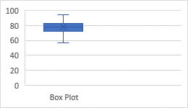

2.34

A) It is right skewed. There is also some data discrepancies between the two graphs which come from the nature of the graphs.

B) The two large bars represent the bimodal. They are like this because the categorized the data into groups.

C) They are both right skewed. The IQR of woman are higher then that of the males. The median time for women is also larger.

D) Marathon times decreased from 1970 – 1974. After that they maintained similar times.